PIZZA SALES SQL QUARIES

1. **KPI’S**
2. **Total Revenue:**

select SUM(total_Price) as [Total Revenue]

from [Pizza DB]..pizza_sales

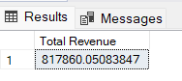

1. **Average Order Value:**

select SUM(total_Price) / count(distinct order_id)as [Average Order Value]

from [Pizza DB]..pizza_sales

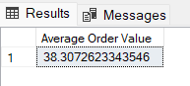

1. **Total Pizza Sold**

select SUM(quantity) as [Total Pizza Sold]

from [Pizza DB]..pizza_sales

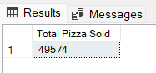

1. **Total Orders**

select COUNT(distinct order_id) as [Total Orders]

from [Pizza DB]..pizza_sales

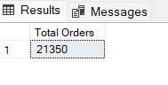

1. **Average Pizzas Per Order**

select cast(cast(SUM(quantity) as decimal (10,2))/ cast(COUNT(distinct order_id) as decimal(10,2)) as decimal(10,2)) as [Average Pizzas Per Order]from pizza_sales

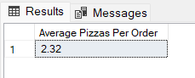

Queries For Chart:-

1. Daily Trend For Total Orders:-

select DATENAME(DW,order_date) as Order_day, COUNT(distinct order_id) as Total_orders

from [Pizza DB]..pizza_sales

group by DATENAME(DW,order_date)

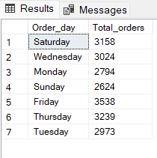

1. Monthly Trend For Total Orders:-

select DATENAME(MONTH,order_date) as Month_name , COUNT(distinct order_id) as Total_orders

from [Pizza DB]..pizza_sales

group by DATENAME(MONTH,order_date)

order by Total_orders desc

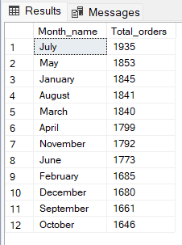

1. Percentage Of Pizza Sales By Pizza Category:-

select pizza_category , cast(sum(total_price) as decimal(10,2)) as total_sales , CAST(SUM(total_price)*100 / (select sum(total_price) from [Pizza DB]..pizza_sales where MONTH(order_date) = 1 ) as decimal(10,2)) as Sales_Percentage

from [Pizza DB]..pizza_sales

where MONTH(order_date) = 1

group by pizza_category

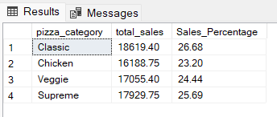

1. Percentage Of Pizza Sales By Pizza Size:-

select pizza_size, cast(sum(total_price) as decimal(10,2)) as total_sales , cast(SUM(total_price)*100 / (select sum(total_price) from [Pizza DB]..pizza_sales where datepart(quarter,order_date) = 1 ) as decimal(10,2)) as Sales_Percentage

from [Pizza DB]..pizza_sales

where datepart(quarter,order_date) = 1

group by pizza_size

order by Sales_Percentage desc

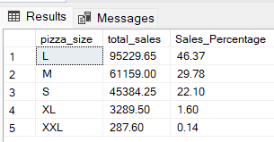

1. Total Pizza Sold By Pizza Category:-

select pizza_category, sum(quantity) as Total_Pizza_Sold

from [Pizza DB]..pizza_sales

group by pizza_category

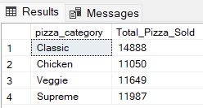

1. Top 5 Best Seller By Total Revenue:-

select top 5 pizza_name, SUM(total_price) as Total_Revenue

from [Pizza DB]..pizza_sales

group by pizza_name

order by Total_Revenue desc

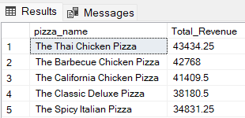

7.Top 5 Best Seller By Total Quantity:-

select top 5 pizza_name, SUM(quantity) as Total_Pizza_Sold

from [Pizza DB]..pizza_sales

where MONTH(order_date) = 8

group by pizza_name

order by Total_Pizza_Sold desc

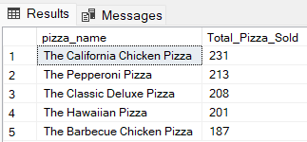

8.Top 5 Best Seller By Total Orders:-

select top 5 pizza_name, count(distinct order_id) as Total_Orders

from [Pizza DB]..pizza_sales

group by pizza_name

order by Total_Orders desc

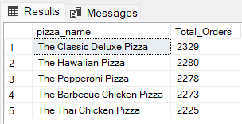

9.Bottom 5 Best Seller By Total Revenue:-

select top 5 pizza_name, SUM(total_price) as Total_Revenue

from [Pizza DB]..pizza_sales

group by pizza_name

order by Total_Revenue asc

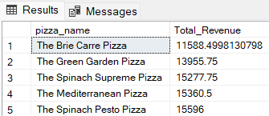

10.Bottom 5 Best Seller By Total Quantity:-

select top 5 pizza_name, SUM(quantity) as Total_Pizza_Sold

from [Pizza DB]..pizza_sales

where MONTH(order_date) = 8

group by pizza_name

order by Total_Pizza_Sold asc

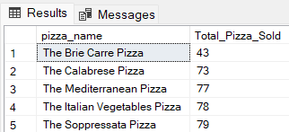

11.Bottom 5 Best Seller By Total Orders:-

select top 5 pizza_name, count(distinct order_id) as Total_Orders

from [Pizza DB]..pizza_sales

group by pizza_name

order by Total_Orders asc

